**Trainee Accounts Executive**

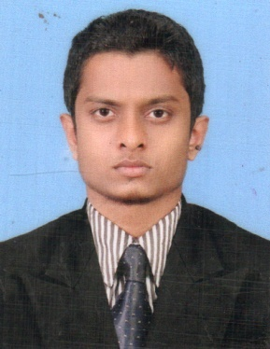

**M.R.M.Azmaan**

Adress - No, 742, kandy Rd, Hingula.   
Mobile - 075 4166473/ 077 6172954  
Email - azmaan01@gmail.com

**Career Objective**

To acquire an entry level position in financial and management field with ITin a leading organization where I can gain continuous development in my career through enhancing my skills while serving the organization with an ultimate goal to achieve a strategic position in management hierarchy

**Professional Qualifications**

* **CIMA - (United Kingdom)**

**2013 - Diploma in Management Accounting** (2013 November session) : ReadingPerformance Operation Financial Operation

Enterprise Operation

**2013 - Certificate in Business Accounting** : Qualified

Management Accounting : 54 Financial Accounting : 56  
Business Mathematics : 56 Business Economics : 50  
Corporate & Business Law : 54

**2013 - Certificate in Information Technology**

Information Systems Basic Graphic design & Microsoft office

Computer

**Academic Qualifications**

* **Passed GCE AL Examination in 2012 (English Medium)** – BCC, Mawanella, , Sri Lanka

Accounting : B Economics : S Business Studies : S

Gen. English : C

* **Passed GCE OL Examination in 2009 (English Medium)** – BCC, Mawanella, , Sri Lanka  
  Mathematics : A English : A ICT : C  
  Religion : A Sinhala : C History : B  
  Science : S Tamil : C English literature : C

**Extra Curricular Activities**

**Special Achievements**

* Merit in National level Young Computer Scientist Competition (2011 & 2012)
* Member of National association of photographer Sri lanka
* Member of "LAMA SABA" association in town council

**Sports Skills:**

* Obtained College level places in Athletic competitions
* member of college cricket team
* member of campus foot Ball team

**Leadership Skills:**

* Member of College Board of Prefects (senior prefect)(2008-12)
* Treasurer of College ICT Club (2011/12)
* Leader of western Band in college

**Language Skills:**

* English : Good verbal communication and writing
* Tamil : Good verbal communication and writing (Native)
* Sinhala : Average verbal communication and writing

**Other Skills:**

* Member of Health club &Art club in college
* Media member of college(photographer)

**Computer Literacy:**

* Diploma in ICT in TCS, Kandy, Sri Lanka (Including Microsoft Office packages)
* Diploma in Graphic Designing in TCS, Kandy, Sri Lanka (Adobe packages & Corel Draw)

**Personal Profile**

* Name In Full : Mohamed Rafeek Mohamed Azmaan
* Date of Birth : 11th of june 1993
* Gender : Male
* Civil status : Single
* Religion : Islam
* National ID : 931630228V
* Nationality : Sri Lankan

**Non Related Referee**

Mr. A.M.M Rizwan

Teacher

Baduriya Central College

Mawanella

🕿 +94 779081832

Mr. M.S.M Nawas

Deputy Principal

Baduriya Central College

Mawanella

🕿 +94 714459949

I hereby certify the information furnished above is true and accurate to my knowledge.

_____________  
**M.R.M Azmaan**